ENVIRONMENTAL POLLUTION
“It’s just one straw. It’s just one bottle. It’s just one plastic bag. It’s just one cigarette stub.”
-said 8 billion people
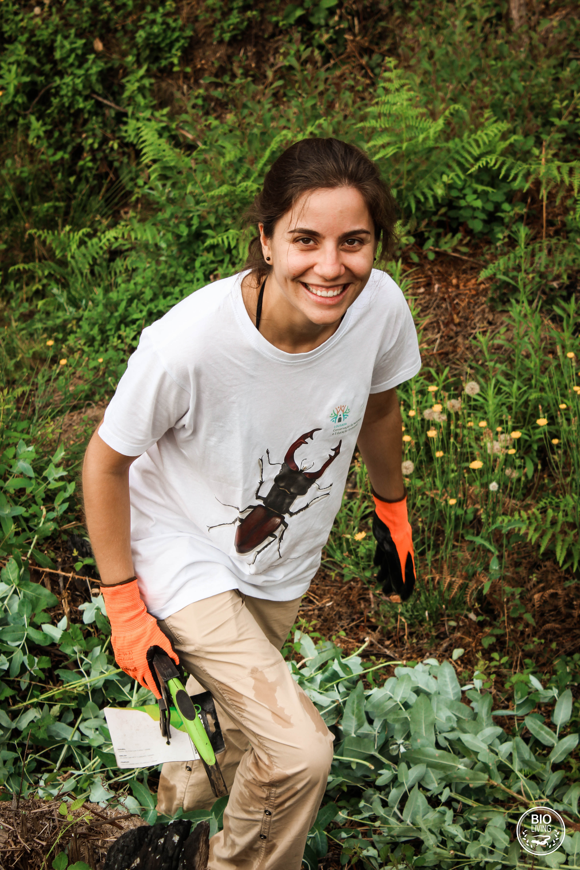
Environmental pollution is no longer a topic that we can ignore since the mankind depends heavily on the environment to survive and it is getting closer and closer to its breaking point. In spite of this, the human beings continue to do activities that weigh heavily on the quality of our environment, constantly being detrimental to it.
To make people a little more aware of this issue, we interviewed a member of the BioLiving association, Sofia Jervis, who explained to us better what we are dealing with...

Team- Hello! Today we are here with Sofia Jervis, a member of the BioLiving association… So, what took you to join an environmental organization?
Sofia- I graduated in Biology at the University of Aveiro but soon realized that I did not want to pursue a research career. I met professors in the Department of Biology who were connected to the area of ​​science communication and I liked the possibility of developing work in that area. In the last year of my degree, I had the opportunity to become an intern, in an environmental NGO, in England for one year, and it was there that I realized that that was what I wanted to do professionally. I was pleased to be able to work directly with people, to involve them and to encourage them to participate actively in environmental issues, to educate them on the importance of nature protection, but, mainly, to see that this work has a positive impact on their lives, in their way of seeing the world and in promoting friendlier and more responsible attitudes. When the opportunity arose to work with BioLiving, I did not hesitate and I said yes!
Team- Tell us more about this association…
Sofia- The BioLiving Association has as motto "Nature and Education for all." As such, our goal is to bring nature to people and to lead people to nature. Our work focuses on four main areas: Nature Conservation (the central component of the Association's activity), which implements actions that benefit the native biodiversity, reduce the negative impact caused by invasive alien species and that raise awareness of natural spaces and values (plantations, sowing, invasive species control, etc); Environmental Education, with actions that promote environmentally and socially responsible attitudes and values, make our flora and fauna known and demystify myths often associated with them; Training, with technical and scientific training in areas such as sustainability and forest management, ecology and biology; and Inclusion and Social Involvement, giving everyone the opportunity to get involved in the activities that are promoted, using nature as the vehicle to fight inequality and, also, encouraging public participation in the defense of green values.
Team- That is interesting! Why did BioLiving decide to focus on picking cigarette stubs in spite of, for example, reducing plastic in Aveiro streets?
Sofia- As a part of our daily activity and of our message of protection and respect for nature, we always promote environmentally friendly attitudes in all areas, which includes, of course, good waste management, recycling, etc. Therefore, we do not approach only cigarette stubs but all the solid waste and the best ways to discard it. We focused our attention on the problem of cigarette stubs pollution caused by man due to our participation in the project of picking cigarette butts in Setúbal, with the organization Feel4Planet. In this action, we were shocked with the number of stubs caught in such a short time and in such a limited space. We realized that the act of throwing them to the ground is already so rooted habit in the smoking population, that it seems socially acceptable, even though it represents such a big environmental problem. From then on, our motivation to get involved in the movement, to alert people and raise public awareness increased.
Team- Have you noticed any difference in Aveiro since you started this project of picking stubs?
Sofia- Yes, absolutely. With the partnership and technical support of BioLiving, we helped, for example, the Municipality of Lousada recover a forest that was very degraded and, at present, it is considered a forest of high conservation value. Additionally, in the Municipality of Albergaria-a-Velha, during these three last years, we have acted in several lands with the intention to transform them into native forests. Altogether, since the beginning of our activity, we have planted (and helped to plant) more than 15000 trees. We have already carried out several projects and fauna and flora inventory activities in several Portuguese places. These inventories allow people to know the species that exist in these places and to see if there are vulnerable species, rare or endemic, so that we can develop and propose conservation plans.
We also believe that reaching as many people as possible is essential if we want to confirm the positive impact on the protection of nature. We only protect what we know and our mission is to make our natural heritage known so that people respect and protect it individually. And, in that sense, we can also reach out to thousands of people with our actions, in the hope that they will continue to pass on the message and adopt eco-friendlier behaviors.
Team- Our class had the same idea. That’s why, in our DAC programme, we decided to go outside to reduce the number of cigarette stubs on the floor. What made you join us in this project?
Sofia- Our partnership in this project came after the contact established with your teachers Guida and Isilda, after they had seen an article that came out in “Público” about one of our projects of picking stubs. We did not hesitate to accept their proposal, of course, since it would be a great opportunity to reach out to the wider public with our #SemFiltros campaign. We were very motivated to see that the younger generation, like you, was also sensitive to this environmental issue!
Team- Thank you so much for that! As an environmentalist, what do you see as the most challenging aspect of your job?
Sofia- The most challenging part of my job is to see the BioLiving Association grow and to be part of that process. We were created three years ago and, until now, we have been able to grow immensely and involve a lot of people in our activities and projects. For me, the greatest challenge of working in an association such as BioLiving is to be on the front line and to develop projects, activities and events that not only give visibility and dimension to the association, but also that have a real impact on the environment and on the lives of the people who participate.
Team- What results do you expect to achieve with the work that the organization has done?
Sofia- The BioLiving Association has still a lot of work to develop and our goals are always adapting to what we are achieving and to what we still want to achieve. In general, we want to continue reaching more and more people through our projects and activities with the aim of encouraging more responsible, conscientious and respectful attitudes towards nature. We also intend to continue promoting contact with nature, which is increasingly declining (especially in urban centers), and to develop nature conservation work with the restoration of degraded habitats and rural areas, in order to promote biodiversity. The BioLiving Association aims to become an environmental NGO of national relevance, continuing to bet on its international dimension, but never forgetting its projects in the local area, which are quite important in the conversation and protection of the local natural heritage.
Team- Do you think the government is doing enough to deal with these environmental issues?
Sofia- In my opinion, the environment is still not a high priority in our country. Fortunately, there are municipalities and local governments that are making a great effort to protect their natural heritage, educate and sensitize the population, like Lousada and Albergaria-a-Velha, with whom we have worked a lot. I think there is a need for more civic participation in environmental issues, so that we can educate people and give them a sense of responsibility for something that is the heritage of each one of us. When the population sees the environment and the protection of nature as a priority, our governments will also do it. Even though the government has a fundamental importance in solving or mitigating environmental issues, protecting the environment is a responsibility of all of us.
Team- If there’s one thing that everyone could do to help protect the environment, what would that be?
Sofia- I think that there isn’t only one attitude that we can embrace to protect the environment but rather a set of actions that we can have in our daily life. The big problem is that most people do not believe that their individual change can have a real impact on protecting the environment, when, in fact, each individual does, especially if we all contribute. In that way, an individual action has a global effect. For example, if we all followed a "zero waste" attitude in our lives, there would be less waste of food, packaging, time, money, etc. and we would have a much reduced ecological footprint. Why buy plastic wrapped products if we can buy the same products in bulk? Why use a plastic bag for each type of fruit or vegetable if we can use cloth bags? Why use disposable products when we can use reusable and long-lasting products?
There is also the issue of consumer education. A large part of the population may not know exactly what they are buying, where their products come from, how they are produced, what they contain in their composition or what impacts they have on the environment. Being informed about these issues allows us to make more conscious choices.
Team- Well, we leave a message here for current and future generations ... There is still hope to save the planet. Sofia, we thank you very much for your presence in this interview and the support that BioLiving has given to our school projects. It was very nice talking to you. Thank you for making time for us!
To conclude, and as the team sees it, the earth’s climate has suffered catastrophic variations and the human activity is considered the main cause of these climatic changes. However, there is still hope that these variations will not become catastrophic if the mankind takes immediate action. As we have seen throughout this interview, every single action that is eco-friendly contributes to a better quality of our future environment. Each bottle, each cigarette stub not lying on the floor are making a difference, even though it seems like an insignificant gesture. That is why we have to get down to work and show society that environmental pollution is a major concern and that we need the support of everyone if we want to live in a world like ours...

Did you know?
Recycling one aluminium can saves enough energy to run your computer for up to 4 hours.

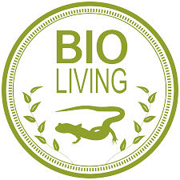

“If you really think the economy is more important than the environment, try holding your breath whilst you count your money.”
- Dr.Guy McPherson
Work done by: Ana Reste, nº1; Mª Inês Guiomar, nº15; Miguel Ressurreição, nº21; Leandra Gomes, nº30

